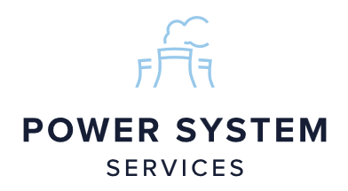 | Ex. Class 2  Job / Works Order  Card PF-2a | Job No | Card No
 | Ex. Class 2  Job / Works Order  Card PF-2a | 10358 | 3355
 | Ex. Class 2  Job / Works Order  Card PF-2a | Date | 06/05/2026
 | Ex. Class 2  Job / Works Order  Card PF-2a | Customer | Street Crane
 | Ex. Class 2  Job / Works Order  Card PF-2a | Project | 10358
 | Ex. Class 2  Job / Works Order  Card PF-2a | Delivery Date | 24/06/2026

ENSURE ALL DRG`S HAVE ‘APPROVED FOR PRODUCTION’ STAMPED IN RED BEFORE THE JOB CARD IS ISSUED TO PRODUCTION
FOR ALL MATERIALS, PLEASE REFER TO AND CHECK AGAINST THE JOBS BILL OF MATERIALS
HEALTH AND SAFETY: | *TURN ALL BOTTLES OFF WHEN NOT IN USE
 | *REPORT ANY DEFECTS OR DAMAGE TO EQUIPMENT
 | *WRAP EXCESS BAGGING ON TROLLEY
 | *PPE - FLAME RETARDANT UNIFORMS, SAFETY GLASSES, EAR PLUGS, GAUNTLETS AND STEEL TOE CAP/STEEL MIDSOLE SAFETY BOOTS REQUIRED

Drawing Number | Rev | Weight | Description | QTY | Parts QTY
220-14151BO |  |  | ZX8 6/8F CRAB CHASSIS SHEAVE SUPPORT CHANNEL | 3
220F50801BO |  |  | ZX6 CT DRIVE REACTION ARM - FABRICATION | 4
22M-15172BO |  |  | ZX8 8/6F LB PARALLEL CRAB CHANNEL ASSEMBLY | 1
22M-15182BO |  |  | ZX8 8/6F LB PARALLEL CRAB CHANNEL ASSEMBLY-MACHINING | 1

WPS Number | Wire Allocation | Qualified Welder ID | Acceptance Criteria

Fabrication and Inspection
Task Description | Operator | Date | Insp By | Date

Final Inspection | Inspector | Date | Signature

